**Administrative API**

The PingFederate Administrative API is a REST-based interface that provides a programmatic way to make configuration changes to PingFederate as an alternative to using the administrative console.

You are prompted for proper administration credentials when you try to perform an API operation.

<https://localhost:7468/pf-admin-api/api-docs/>

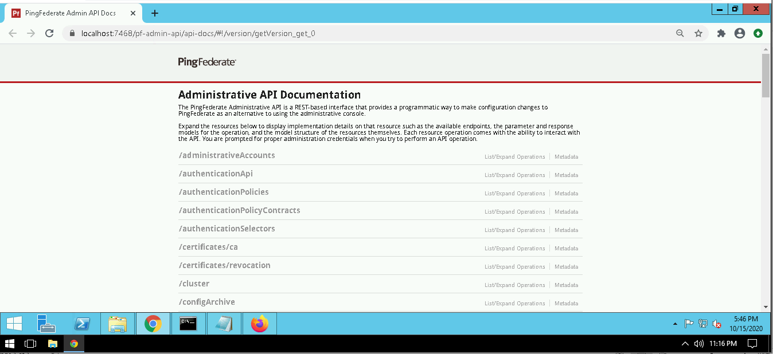

**Let’s test API’s**

**->>> Test for Version of PingFederate**

[**https://localhost:7468/pf-admin-api/v1/version**](https://localhost:7468/pf-admin-api/v1/version)

Try to access in browser

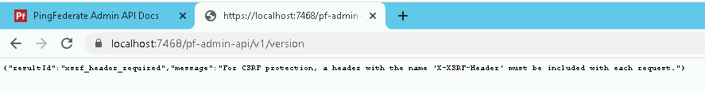

**{"resultId":"xsrf_header_required","message":"For CSRF protection, a header with the name 'X-XSRF-Header' must be included with each request."}**

**We need to add a Header in http request**

**X-Xsrf-Header: PingFederate**

**Header Name : X-Xsrf-Header**

**Header Value : PingFederate**

* **We can add Extension in chrome or any other browser to add Headers in http request.**

**Add ModHeader Extension**



**Now add the Header name and value in extension**

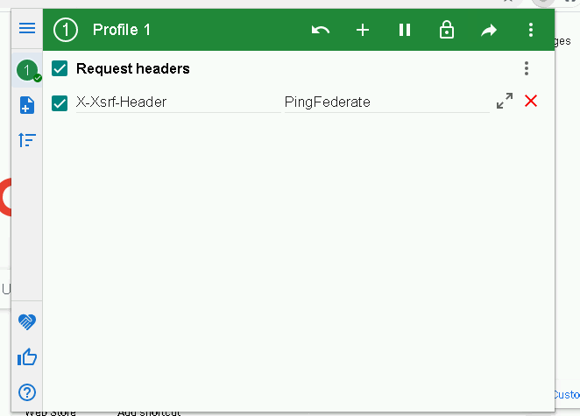

**Now try to access the API to know the version of PingFederate**

**It will prompt for Authentication**

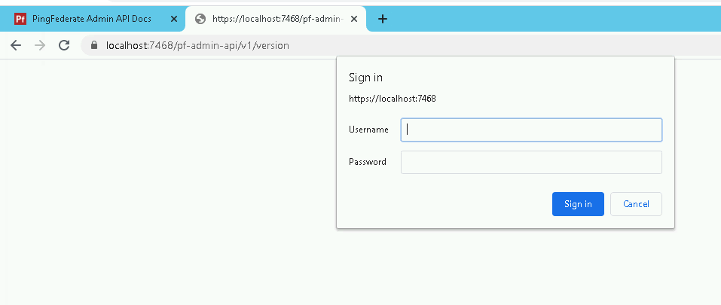

**Entered the Administrator Credential**

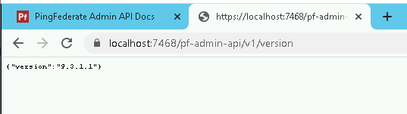

**{"version":"9.3.1.1"}**